**Yantra Script Results - Fixed Change FNN**

**Test Case 01 :**

**Script Name:** Fixed Chown

**Scenario:** Add New

**Order Id:** fixedchown23oid1715850168089

**Episode Id:** FJ251715850192270

**Yantra Script:**

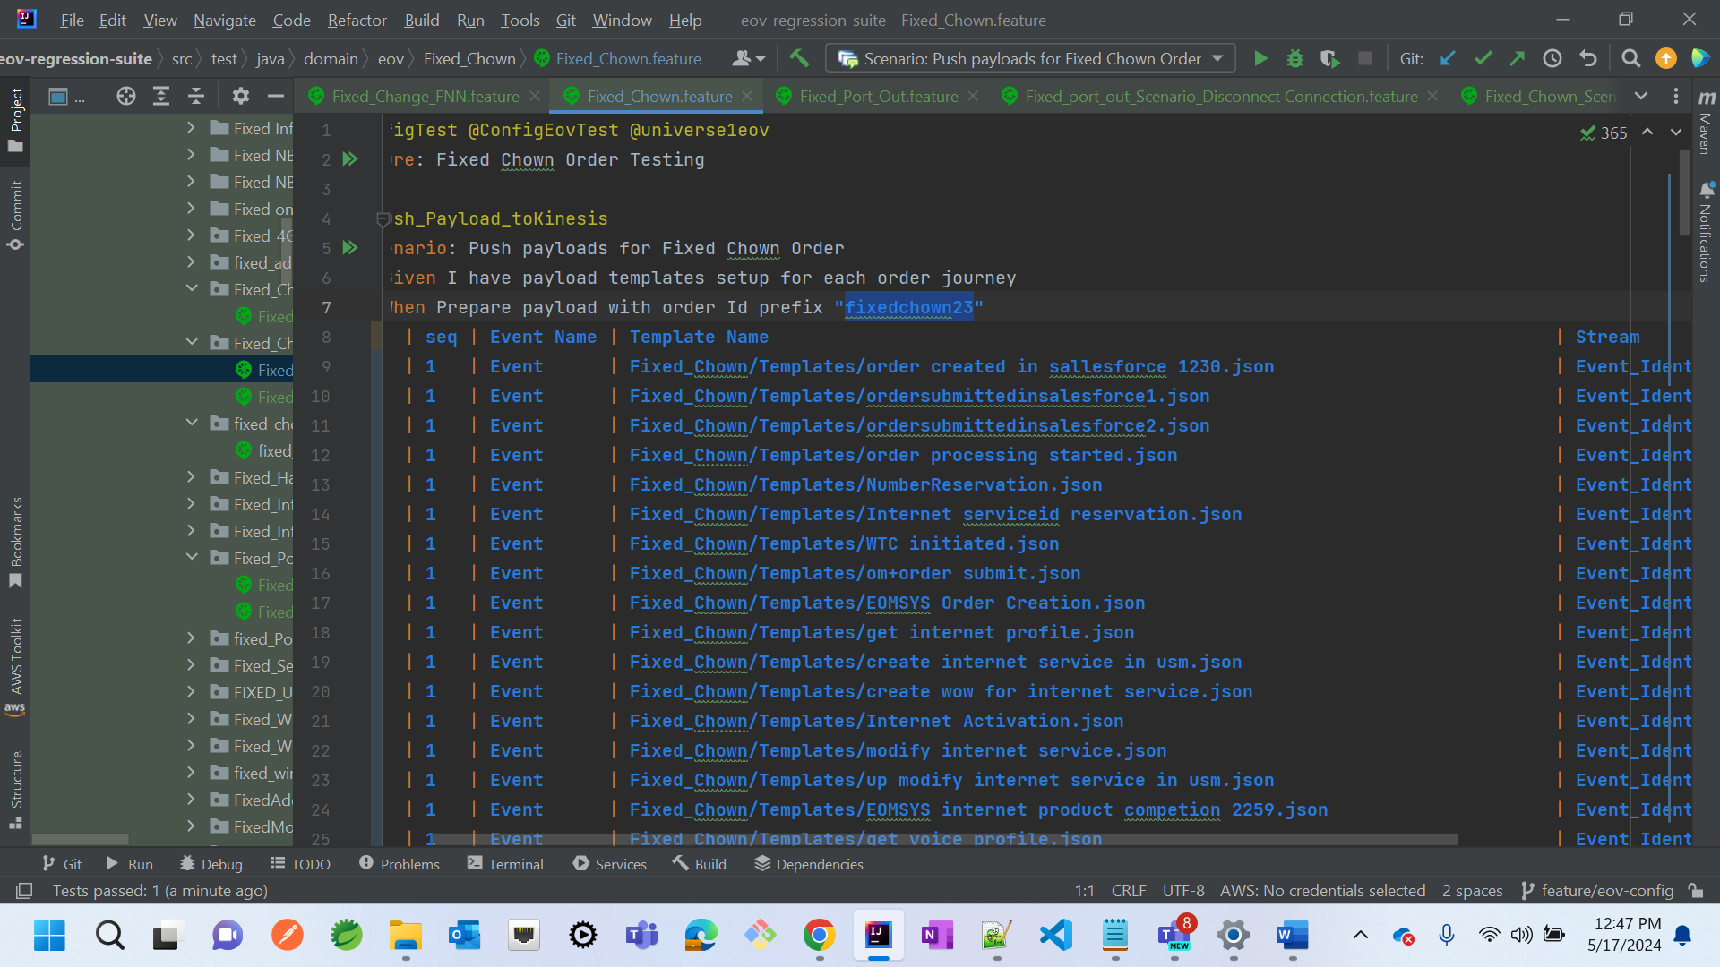

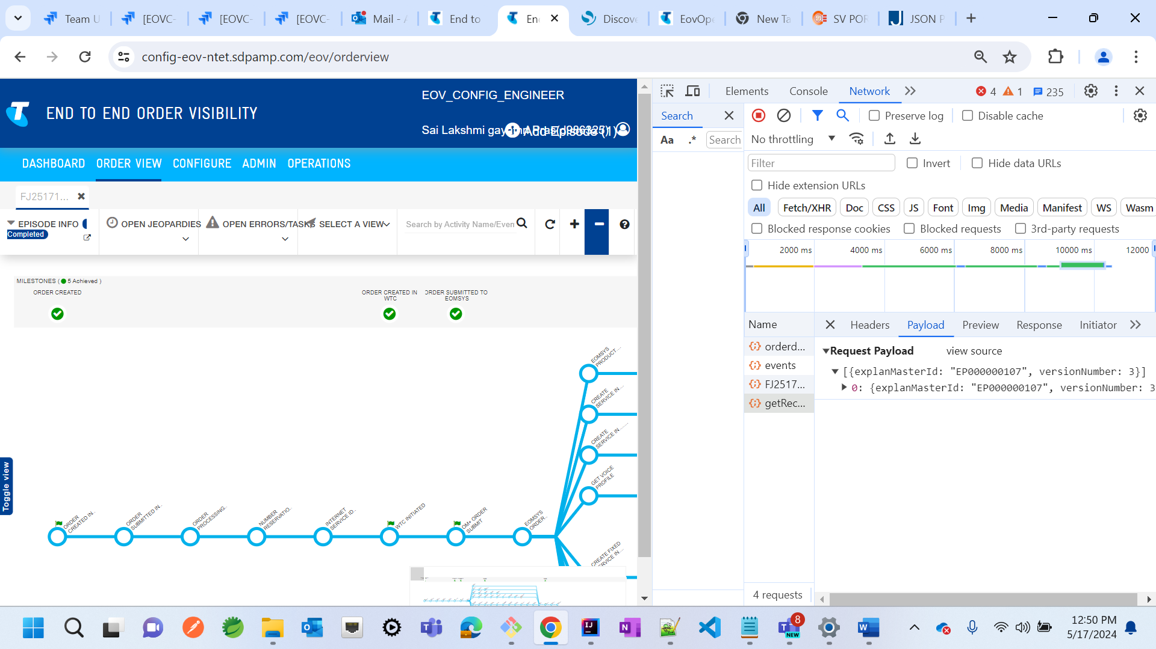

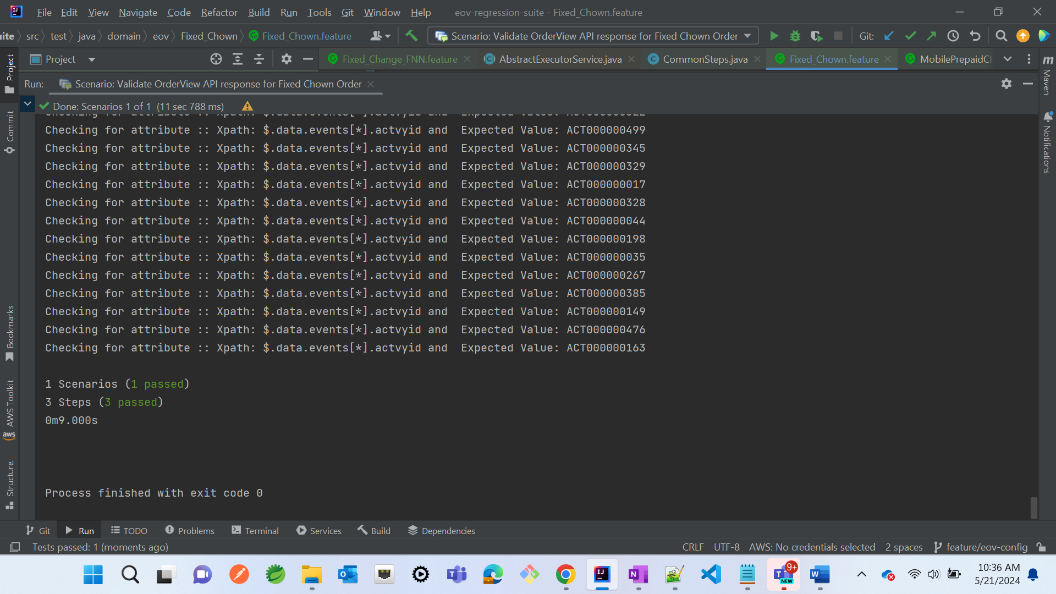

**Test Case 02 :**

**Script Name:** Fixed Chown

**Scenario:** Add Connection

**Order Id:** fixedchown24oid1715850260926

**Episode Id:**

Yantra Script:

